9.8: (a) The angular acceleration is positive, since the angular velocity increases steadily from a negative value to a positive value.

(b) The angular acceleration is

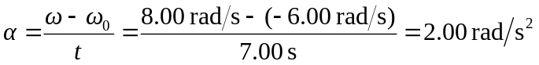

Thus it takes 3.00 seconds for the wheel to stop 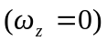. During this time its speed is decreasing. For the next 4.00 s its speed is increasing from 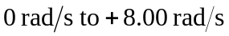.
(c) We have
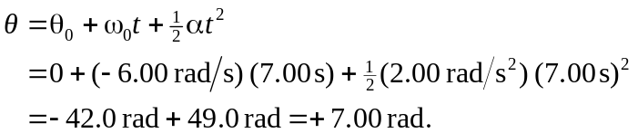
Alternatively, the average angular velocity is

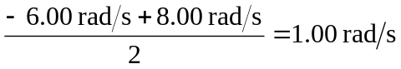
Which leads to displacement of 7.00 rad after 7.00 s.

